Platform as a Service (PaaS)
# Source: AI Source: Provided by: [Data Path: Persons Table -> ID Column: 1, Name_En Column: Motasem Essam] -> From: [ChatGPT] on [1/16/2026]
PaaS is a cloud computing service model that provides a platform for developers to build, deploy, and manage applications over the Internet without worrying about the underlying infrastructure.
It sits between IaaS and SaaS, giving developers tools to focus on coding and deployment instead of hardware and OS management.

Definition
# Source: AI Source: Provided by: [Data Path: Persons Table -> ID Column: 1, Name_En Column: Motasem Essam] -> From: [ChatGPT] on [1/16/2026]
PaaS:
- Provides hardware and software tools hosted by a cloud provider
- Users focus on application development
- Provider manages servers, storage, networking, OS, and middleware

Architecture Diagram
# Source: AI Source: Provided by: [Data Path: Persons Table -> ID Column: 1, Name_En Column: Motasem Essam] -> From: [ChatGPT] on [1/16/2026]
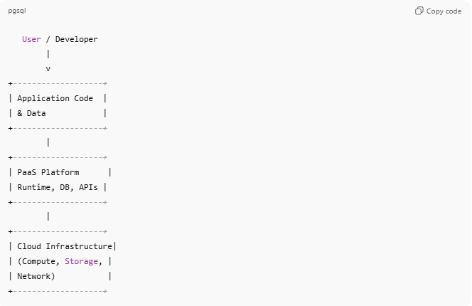
User / Developer
|
v
+-------------------+
| Application Code |
| & Data |
+-------------------+
|
+-------------------+
| PaaS Platform |
| Runtime, DB, APIs |
+-------------------+
|
+-------------------+
| Cloud Infrastructure|
| (Compute, Storage, |
| Network) |
+-------------------+
- User responsibility: Application code and data
- Provider responsibility: OS, runtime, middleware, infrastructure

Key Features
# Source: AI Source: Provided by: [Data Path: Persons Table -> ID Column: 1, Name_En Column: Motasem Essam] -> From: [ChatGPT] on [1/16/2026]
- Provides development tools, runtime environments, and databases
- Handles scaling, load balancing, and updates automatically
- Supports multiple programming languages and frameworks
- Allows rapid development and deployment

Examples
# Source: AI Source: Provided by: [Data Path: Persons Table -> ID Column: 1, Name_En Column: Motasem Essam] -> From: [ChatGPT] on [1/16/2026]
- Google App Engine – Deploy apps without managing servers
- Microsoft Azure App Service – Web and mobile app development
- Heroku – Cloud platform for deploying applications quickly
- Red Hat OpenShift – PaaS for enterprise apps

Advantages
# Source: AI Source: Provided by: [Data Path: Persons Table -> ID Column: 1, Name_En Column: Motasem Essam] -> From: [ChatGPT] on [1/16/2026]
- Developers focus on application logic, not infrastructure
- Faster time-to-market for applications
- Automatic scaling and maintenance
- Cost-effective: pay for the platform and resources used

Disadvantages
# Source: AI Source: Provided by: [Data Path: Persons Table -> ID Column: 1, Name_En Column: Motasem Essam] -> From: [ChatGPT] on [1/16/2026]
- Limited control over underlying infrastructure
- Vendor lock-in for platform-specific tools or frameworks
- Less flexibility compared to IaaS for custom configurations

Simple Analogy
# Source: AI Source: Provided by: [Data Path: Persons Table -> ID Column: 1, Name_En Column: Motasem Essam] -> From: [ChatGPT] on [1/16/2026]
- PaaS: Renting a fully furnished and equipped office
  - You bring your work (application code)
  - Office provider handles furniture, electricity, internet, and maintenance (OS, runtime, database, infrastructure)

